# EDUCATION

Borno state has the highest percentage number of schools which is 39.5% of the total , more than 3000 schools in IDP sites. It is followed closely by Adamawa which is 24.1% close to 2000 schools. The state with the least number of school is Gombe at 8.4% , followed closely by Bauchi at 8.5%

# 

37.4% of the sites had not enough teachers /volunteers that are available and complained that the classrooms are quite/often crowded while 12.3% of the sites have largely insufficient number of teachers/volunteers available. 27.6% recorded that they are enough teachers/volunteer available, but the classrooms are a little bit/sometimes crowded while 22.6% of sites responded that they have enough teachers/volunteers available and the classrooms are not so crowded.

We can infer that 49.7% of the staff don’t have enough teachers/volunteers and classrooms are not in good condition

# 

62.0% of IDP sites have the nearest education facility less than 1km while 27.6% have it less than 2 km and 4.6% have it less than 5km. Only 0.3% have it greater than 10km and 0.5% have it less than 10km.

This means education facility have a closer distance to where the children live

# 

45.7% of the children at the site attending school only have 25% to 50% attendance rate , while only 6.6% have a school attendance rate that is greater than 75%.

27.5% have their attendance rate between 51% to 75% .

13.9% of the children have an attendance rate of less than 25% and 6.4% didn’t attend school.

This shows low attendance rate in IDP sites despite the close distance to an education facility

# 

# 

We have more female teachers(55.3%) than male teachers() in borno

Yobe has more male teachers(8.4%) than female teachers(5.5%)

# 

45.5% of idp sites in nigeria have classrooms that are crowded and 32.4% have classrooms not crowded. 22.1% of them have no enough learning space that can accomodate students

# 

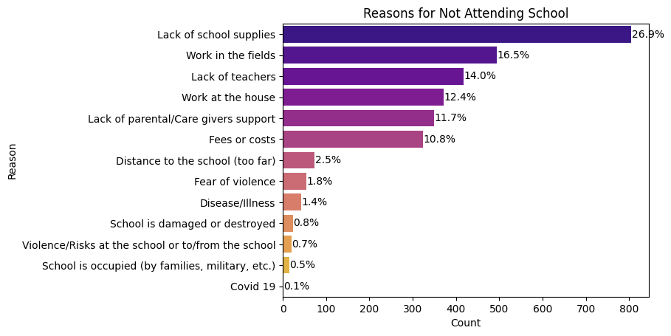Fees or costs ,lack of school supplies and work at the house are the top major reasons children don't attend schools in IDP sites

# 

78.4% of the idp sites have ministry of education trained teachers in their community while 21.6% do not.

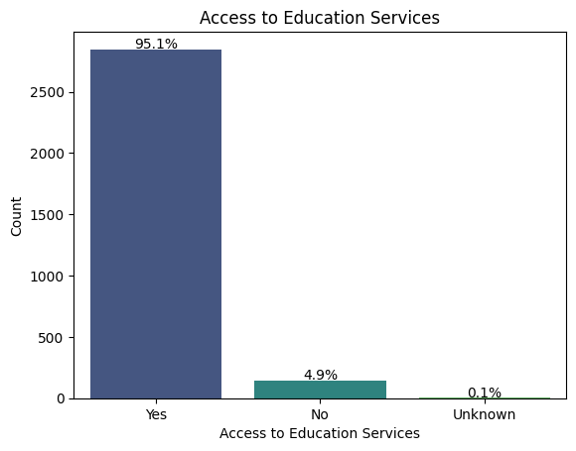

95.1% signifying an high access to education services in idp sites in the country ,only a fractional amount 4.9% do have access to education services

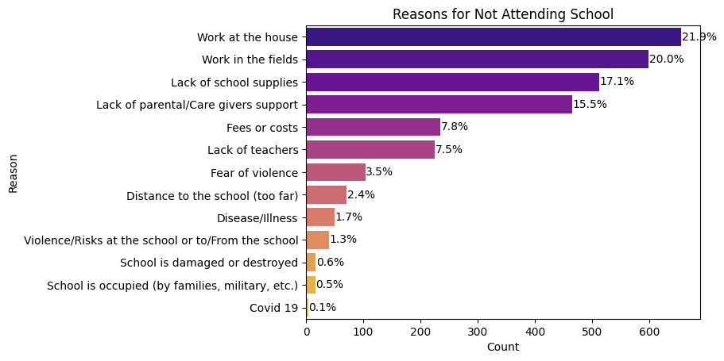

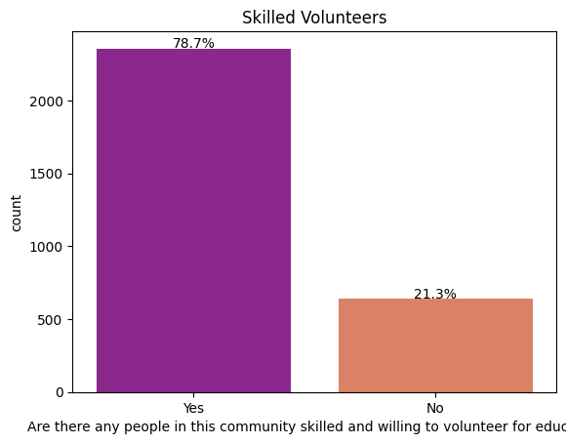

78.7% of sites have people in their community that are skilled and willing to volunteer for education while 21.3% don’t have that

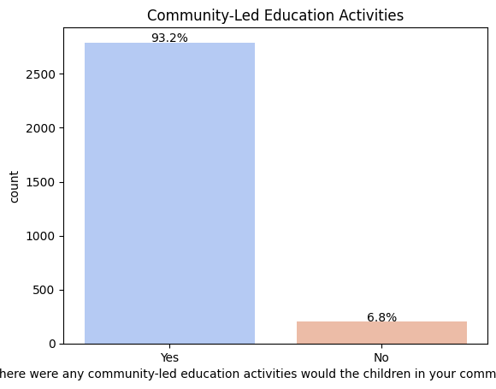

In 93.2% of the idp sites ,there was community led education activities carried out while 6.8% do not

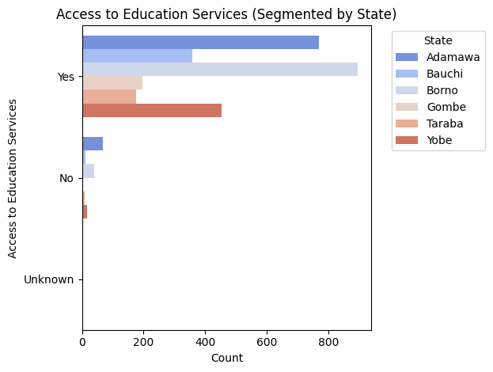

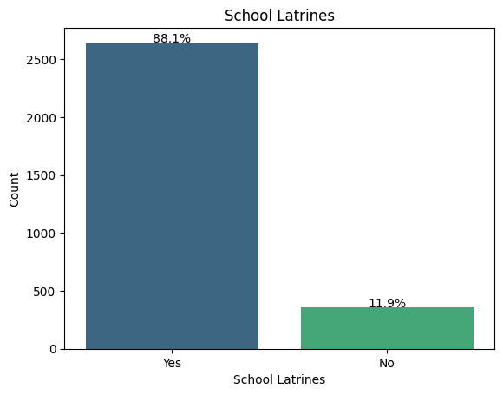

88.1% of schools in IDP sites have school latrines available , only 11.9% do not

# DEMOGRAPHICS & DISPLACEMENT

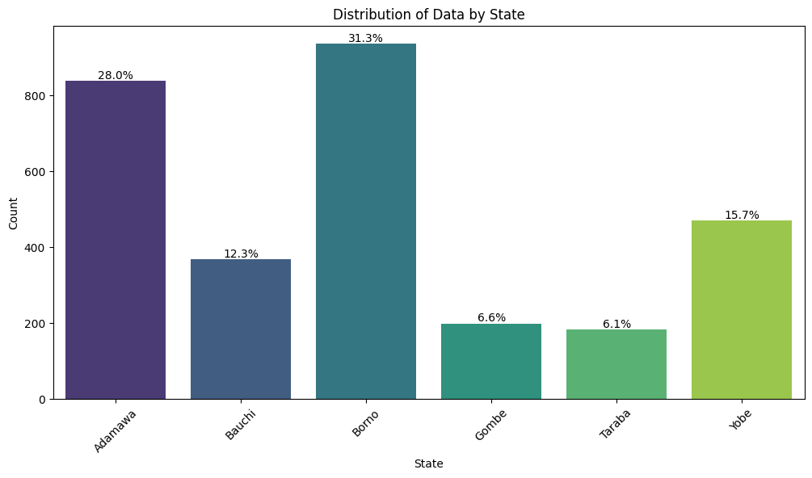Borno state has the highest idp sites 31.3% , adamawa has 28%,yobe has 15.7%,Bauchi has 12.3% ,gombe is 6.6% and the least,taraba is 6.1%

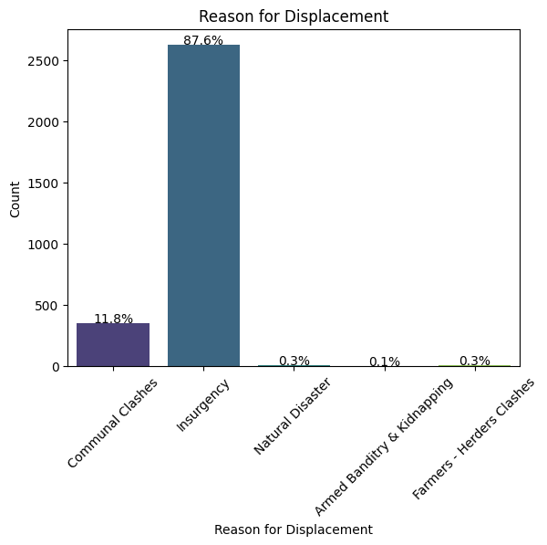

87.6% of the reason for displacement is due to insurgency which is reflective of the north eastern part of nigeria due to insecurity

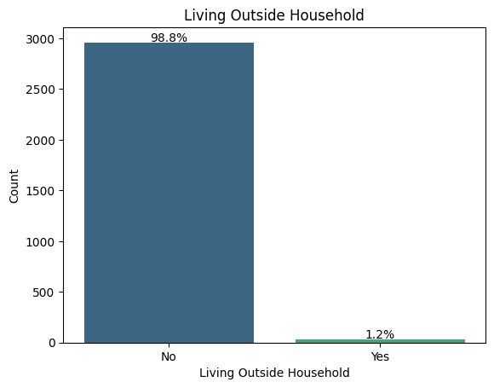

Most of the sites do not live outside their household

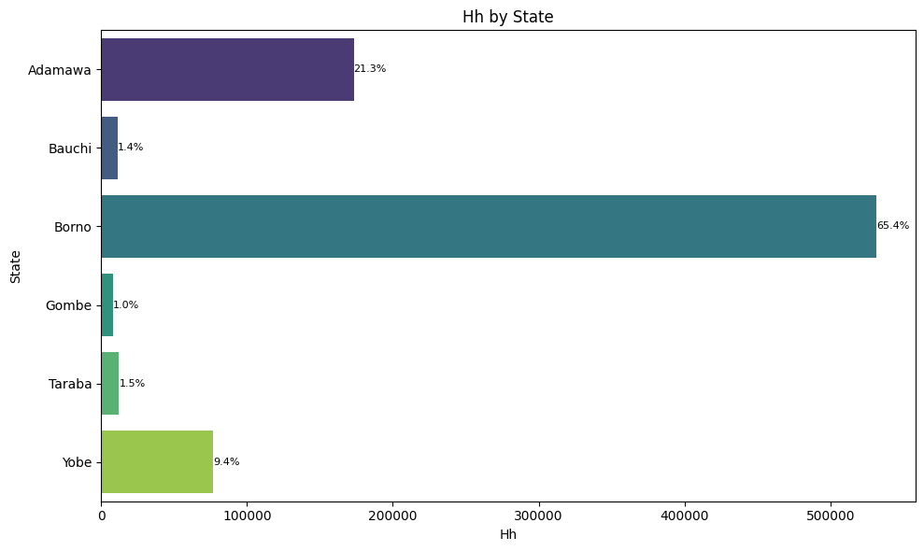Taraba had more household than bauchi and Gombe.althought this is negligibe

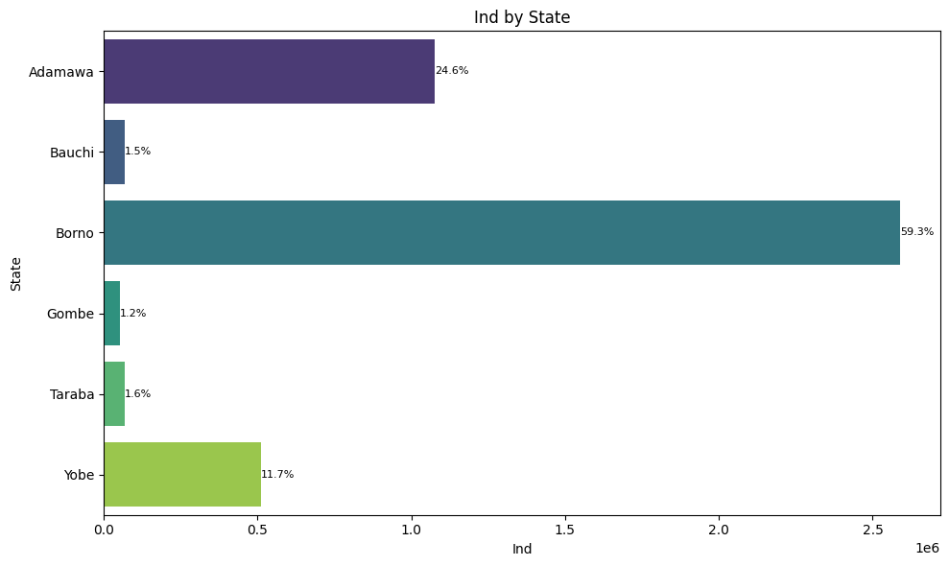

Taraba also had more individuals compared to bauchi and Gombe

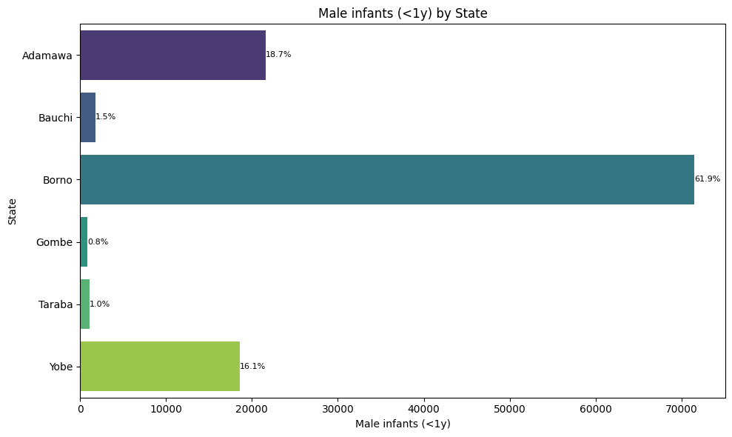

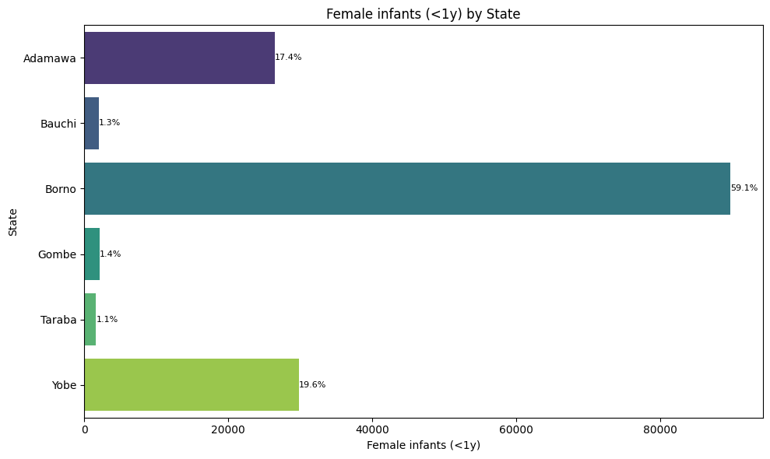Yobe has more female infants that are less than 1 year recorded than adamawa

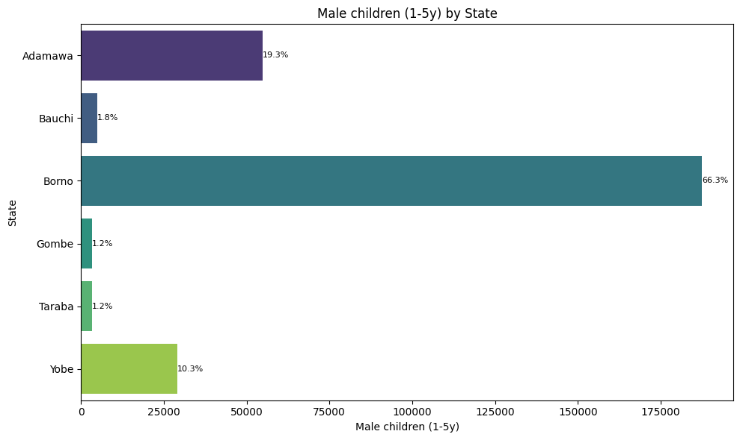

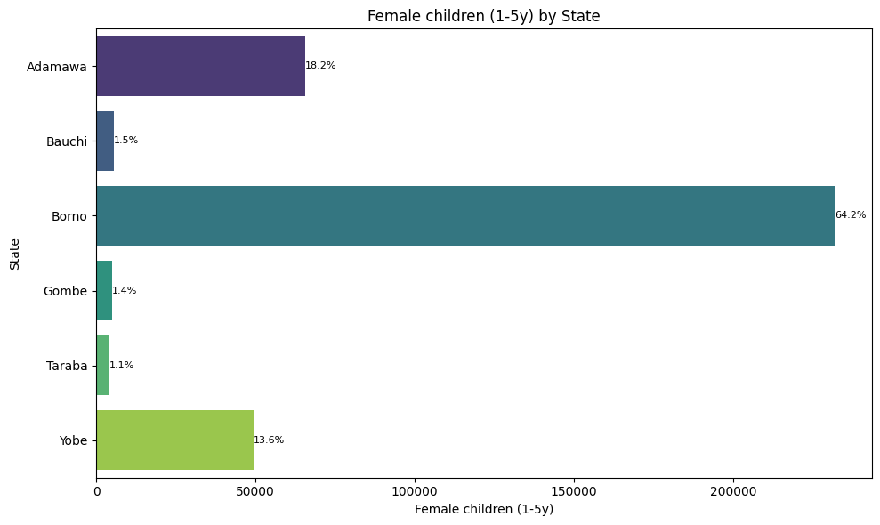

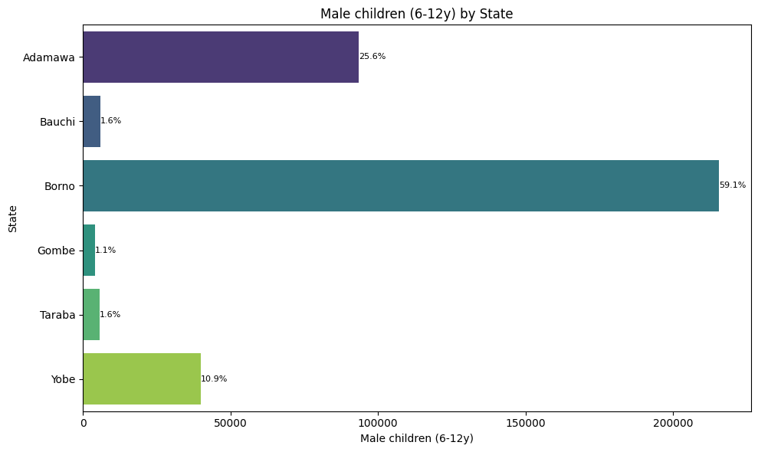

Taraba has more male children between 6-12 years than gombe and bauchi

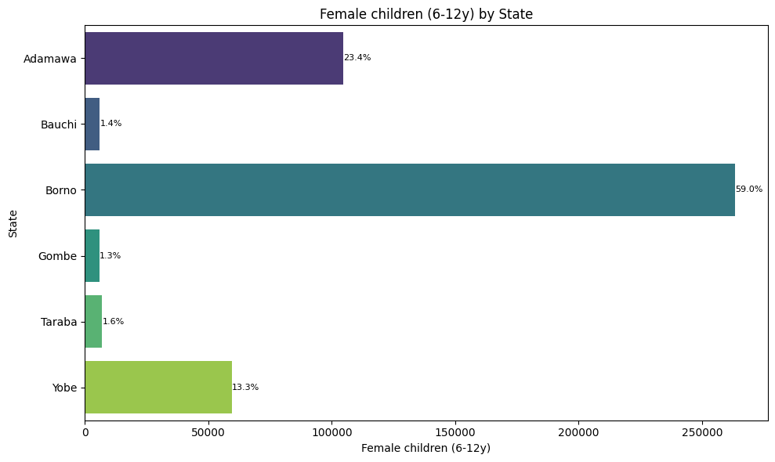

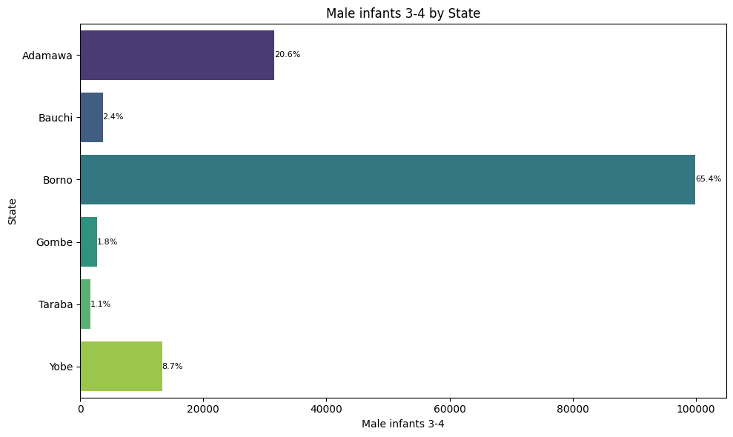

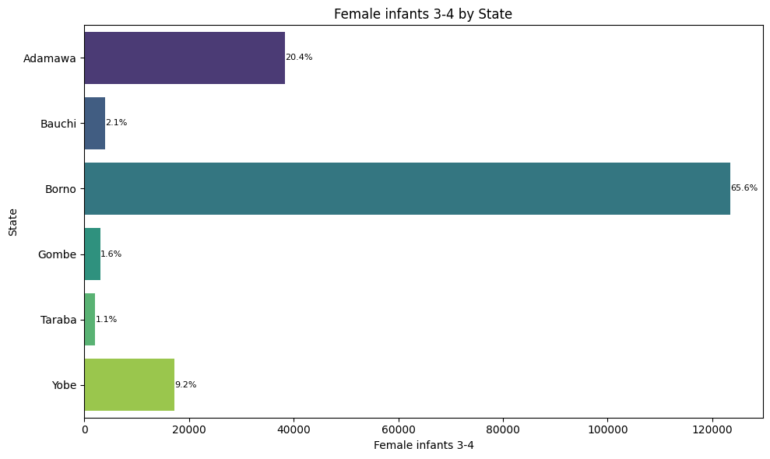

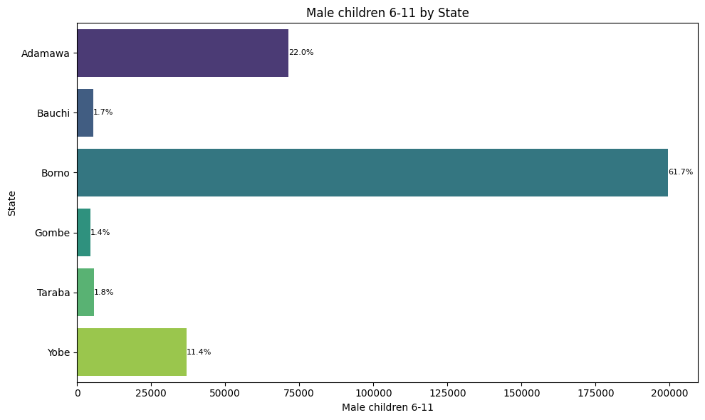

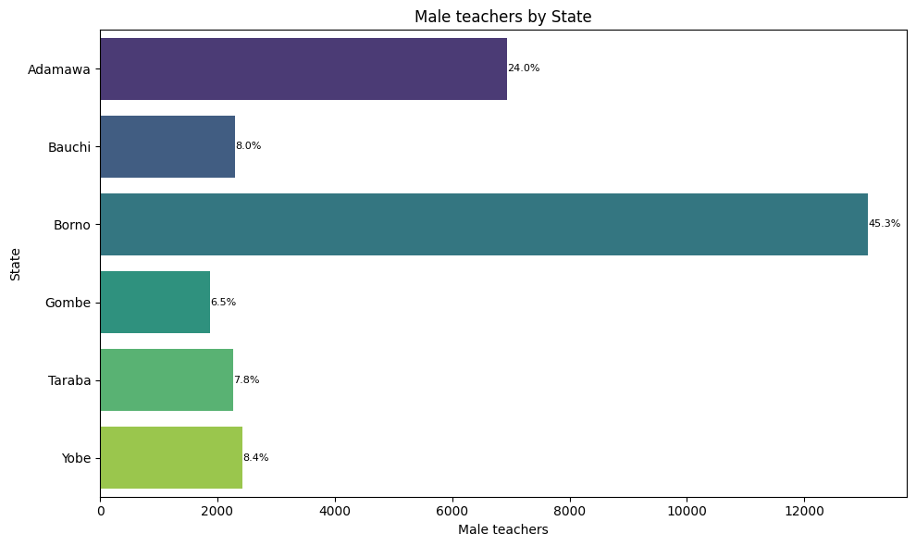

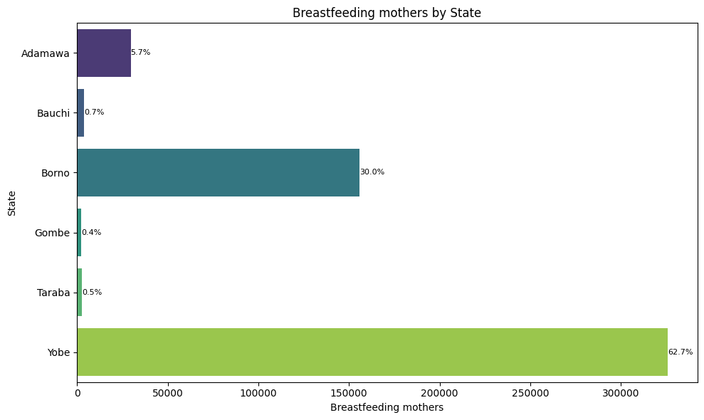

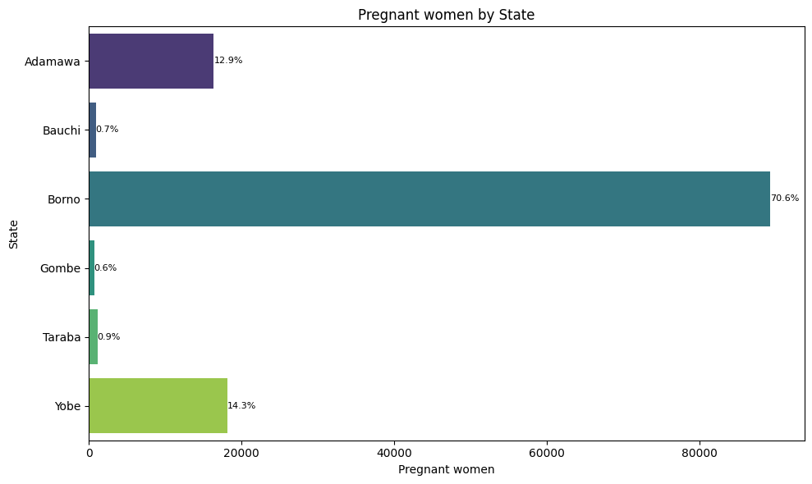

Yobe has more pregnant women with 14.3% more than adamawa 12.9%

# SITE CHARACTERISTICS & SECURITY

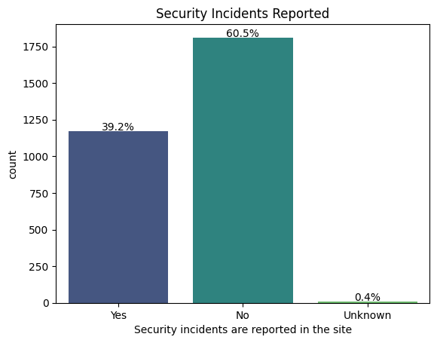

60.5% reported that security incidents were not reported in the site. While 39.2% reported there was security incidents in the site

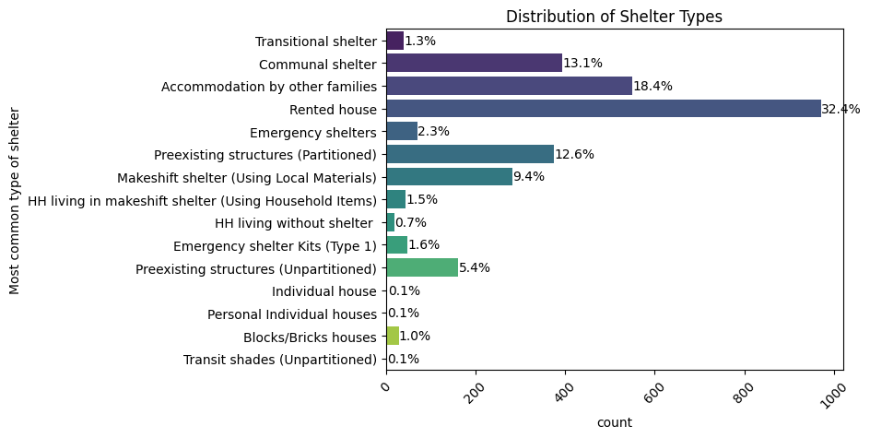

32.4% of occupants in idp sites live in rented house followed by 18.4% that live in an accomodation by other families

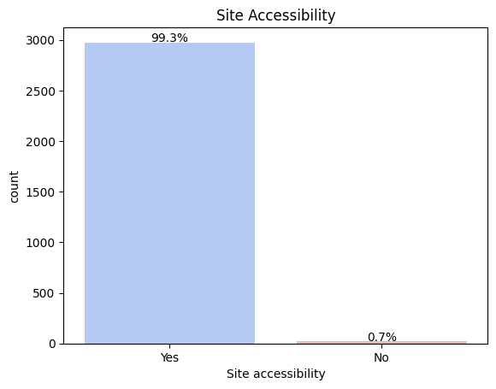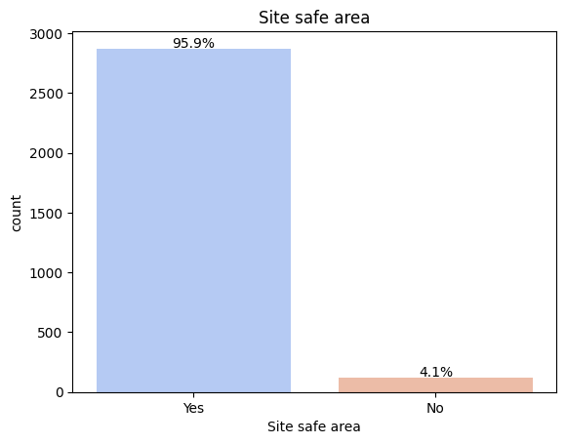

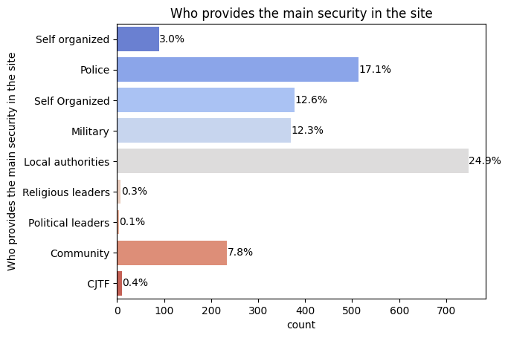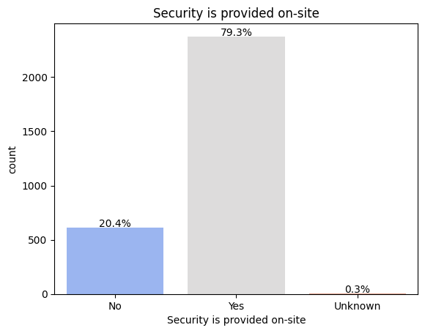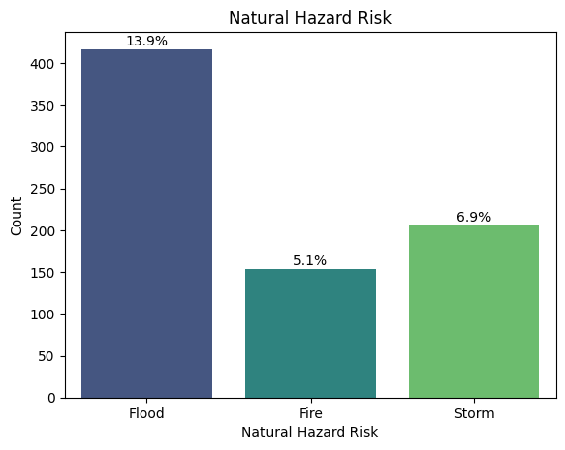

# HEALTH & NUTRITION

Government is the owner of 81.9% of the health facility in displaced sites followed by NGO’s.

52.6% of people in idp sites have regukar access to medicine through the health faciltiy while only 36.7% have their regular access to the chemist shop

malaria is the most prevalent health problem in idp sites holding 70.7% of occurence in most idp site

64.1% have not be screened for malnutrition using muac while 34.7% have been screened for malnutrition

96% of IDP sites responded that they have access to health services

74.2% of idp sites don't have supplementary feeding while 24,3% responded

majority of nutrition is distributed 25.9% onsite which is less than 30mins and the lest 7,7% have less than 3hrs and it is off site

majority of the location of their main water source is the on site and it is within 30 minutes of reach

there is no complaint about drinking water quality

86.5% of the toilet condition of IDP Sites are not so good(not hygienic)

53.8% ,Majority of Health facilities services are located on-site usually less than 3km to the displaced sites while 23.8% of health facilities service are located off site and are also less than 3km

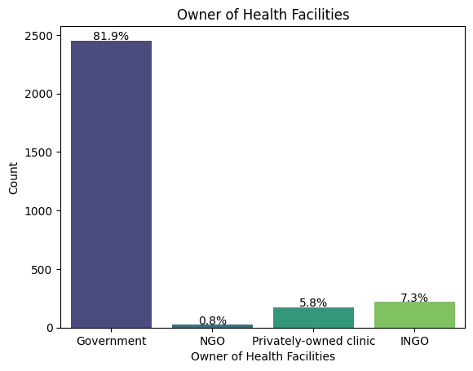

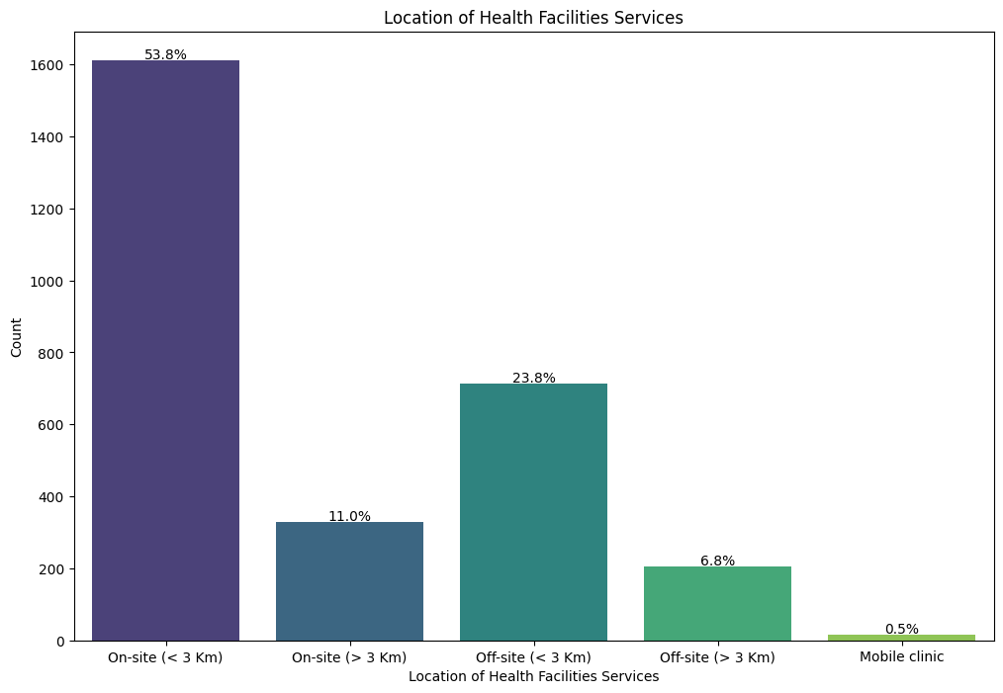

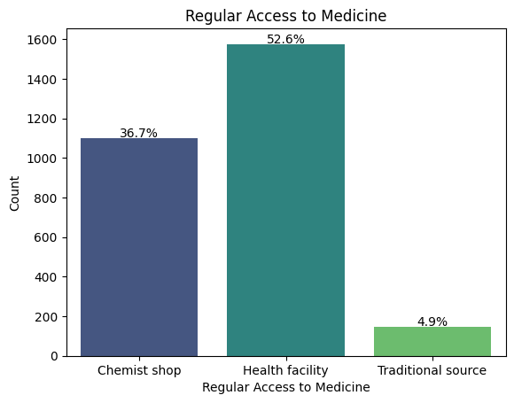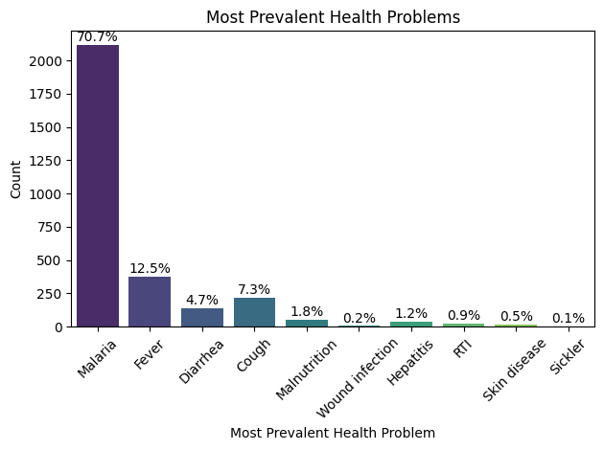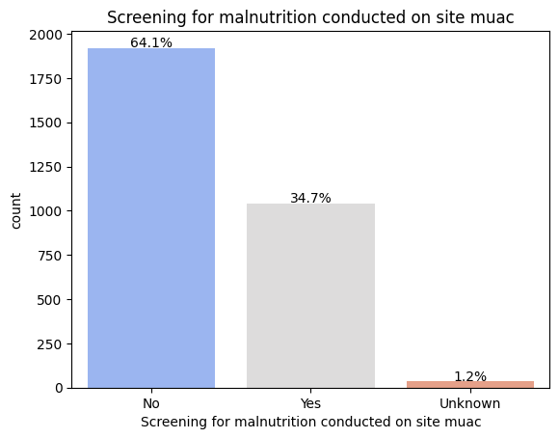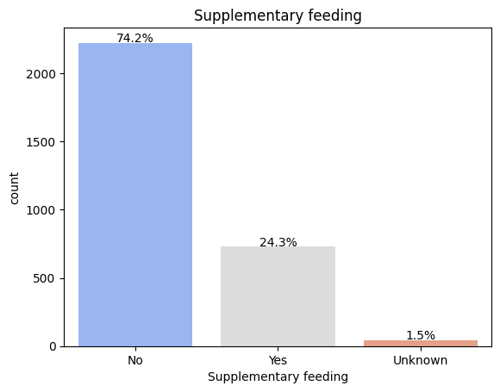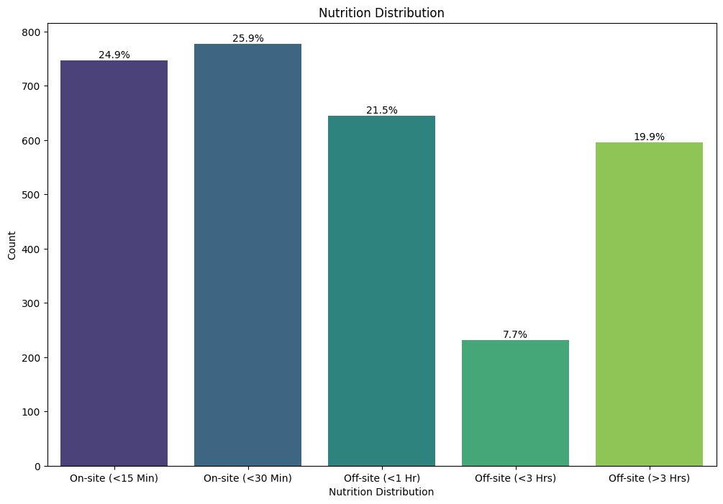

# WASH (Water, Sanitation & Hygiene)

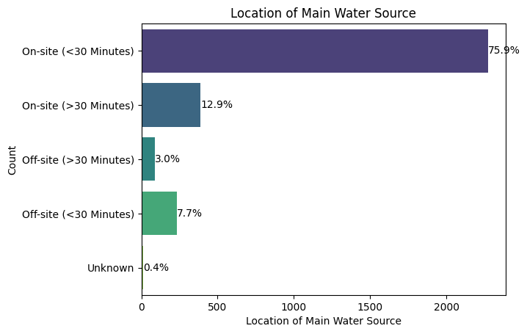

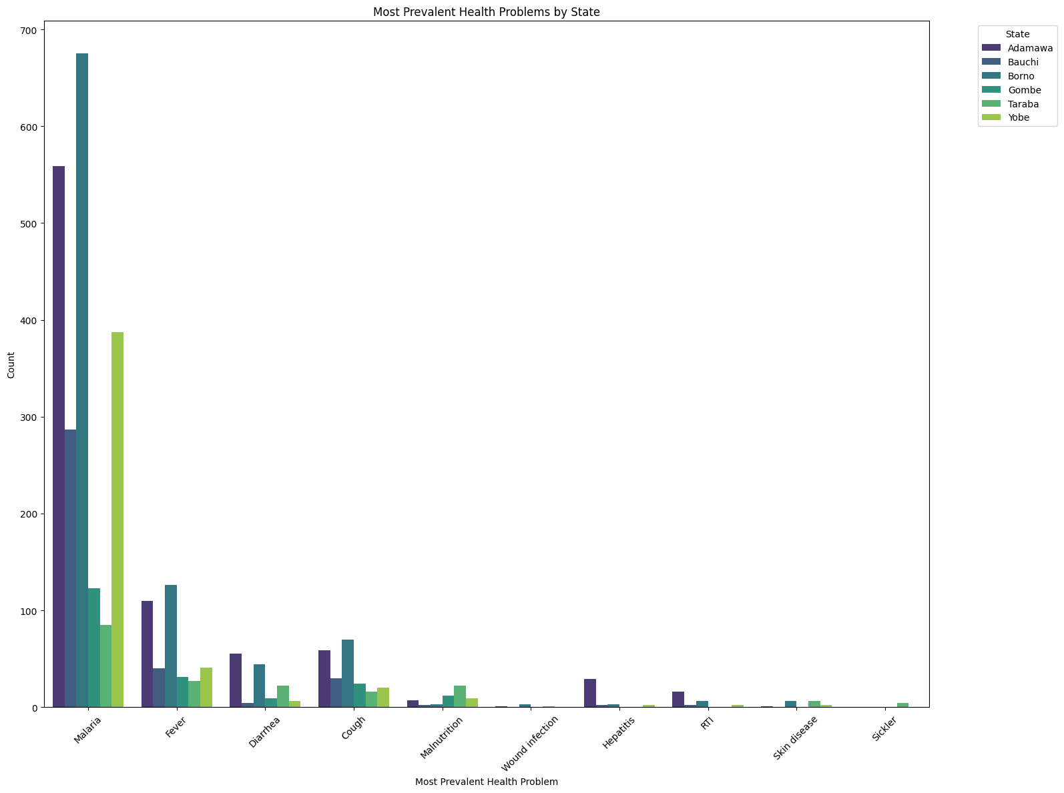

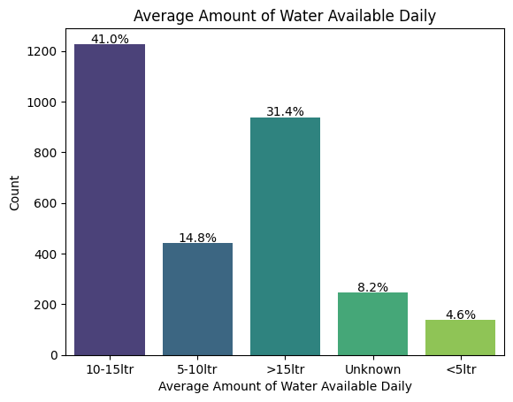

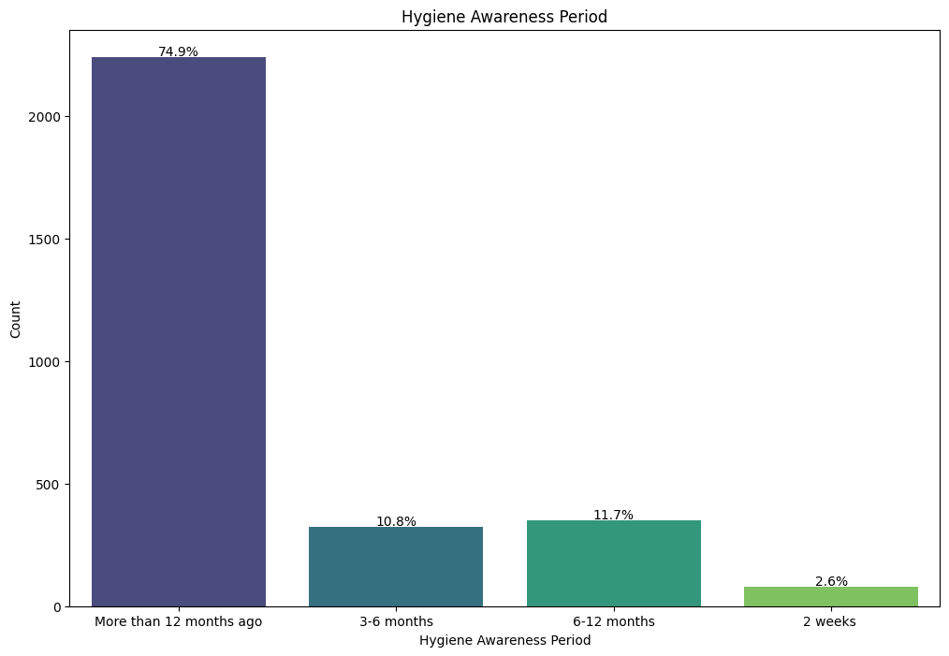

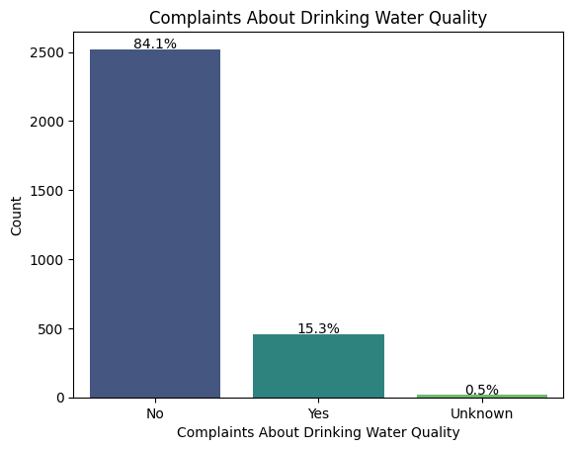

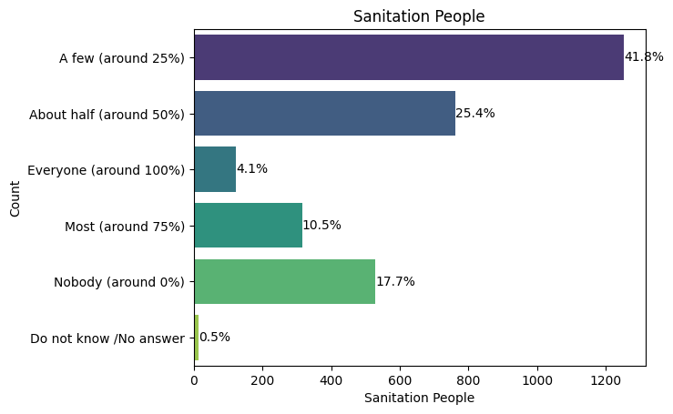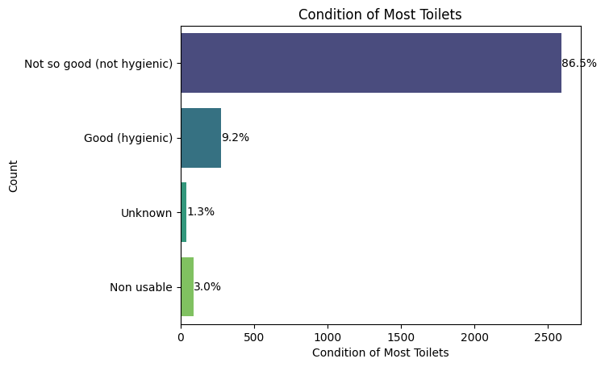

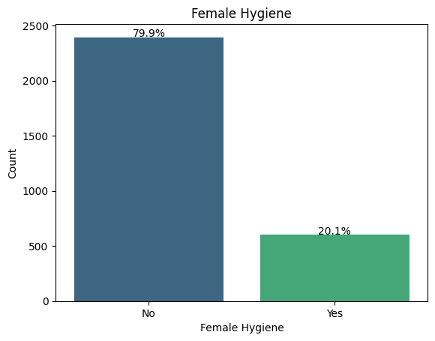

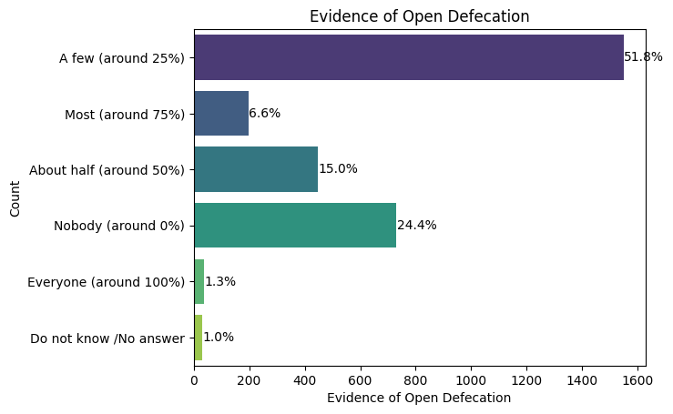

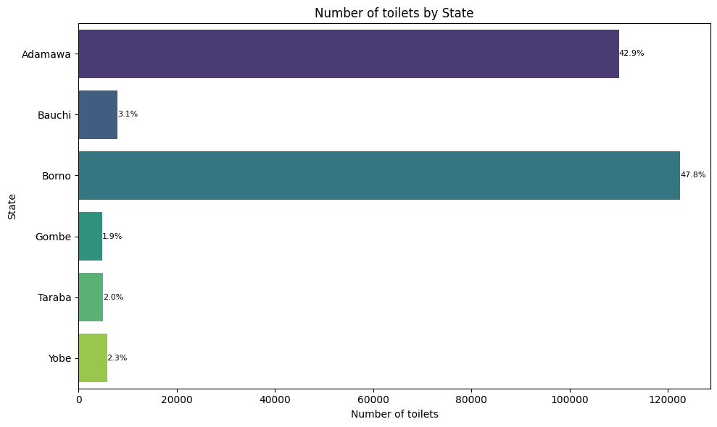

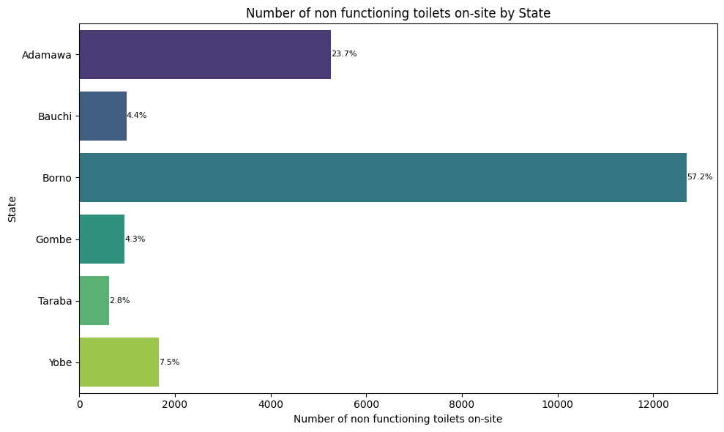

# FOOD SECURITY & LIVELIHOODS

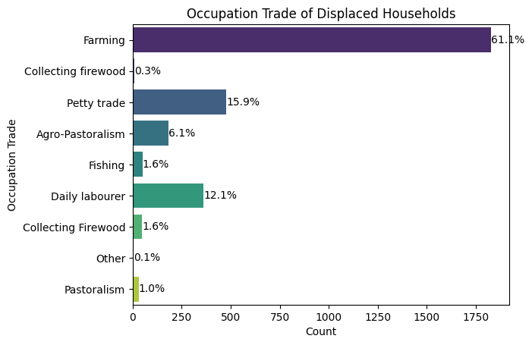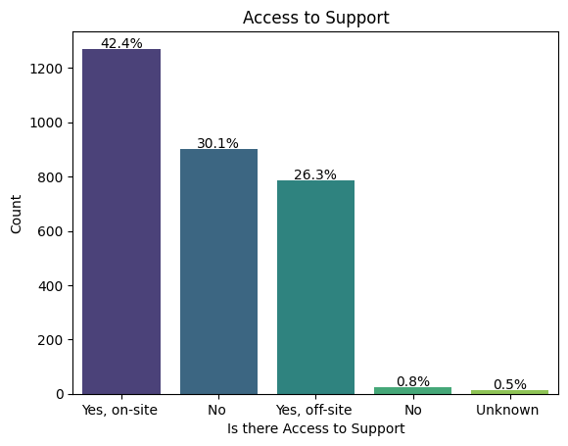

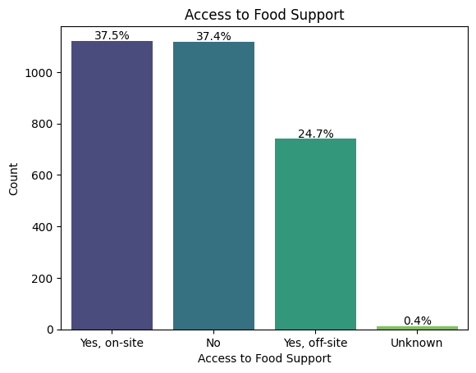

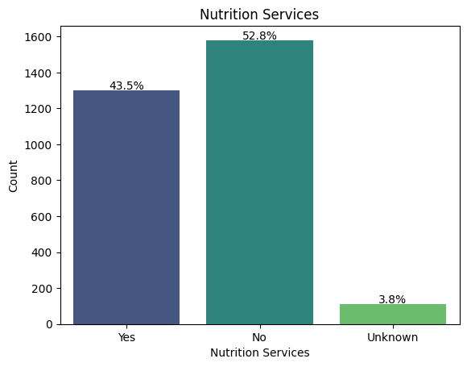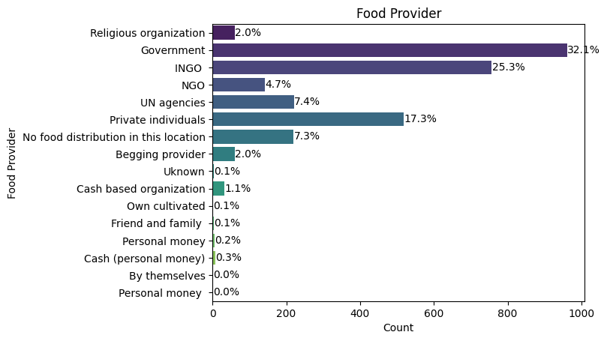

# NEEDS & SUPPORT

